* 1. Docker ps -a

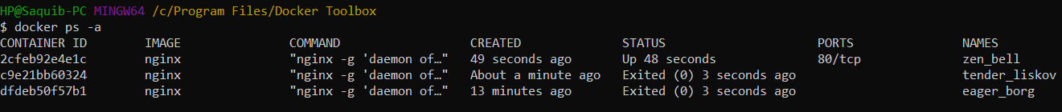

1.2 Docker ps -as



1.2 Docker images



1.3 Secret Answer

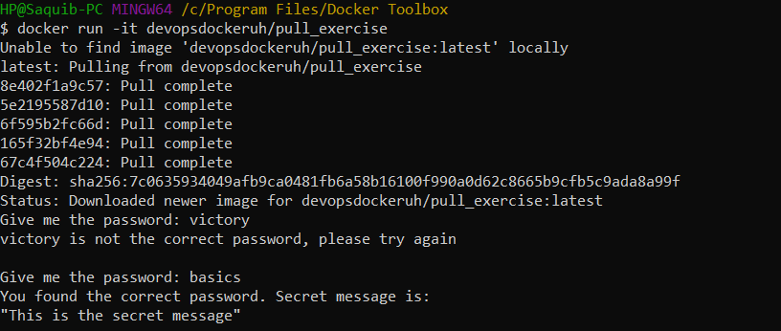

1.4 secret message

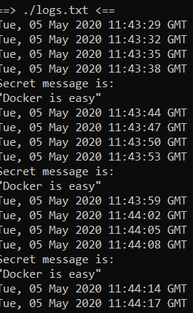

1.5 helsinki.fi

